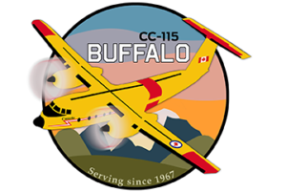
  - Comox valley
Afternoon activity ideas

Golf
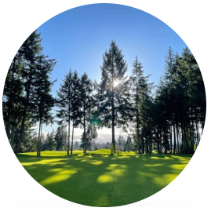
Glacier Greens – Mountain views and next door to the airport a “hidden gem” for golf
Crown Isle – A championship 18 hole course and a Par 3 available

Wineries
Beaufort – tasting by booking. Onsite picnic area
with wine for purchase
40 Knots – Tasting available for booking

Hiking
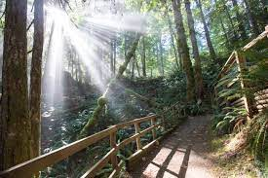
There are many hiking trail throughout the Valley and in the surrounding area. Some local easy access favorites are below.
Seal bay – for easy paths of different lengths
Nymph Falls – easy paths of different lengths
Goose Spit – Explore the beach

Museum
Comox Air Force Museum

Explore Cumberland
Old coal mining town reimagined. Quiet Main Street with local shops, brewery and restaurants to explore. Surround by a forest full of an expansive trail network for all levels of biking. There is something for everyone.

For more great ideas check out Explore Comox Valley Guidebooks Here

